

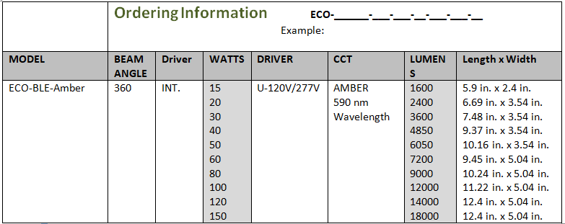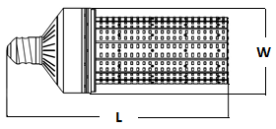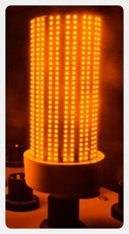

Application

The BLE Amber series LED retrofit lamp is specifically designed to replace HID, MH, and HPS lamps in Amber Light Applications requiring 590 nm Wavelength providing 60-90 percent in energy savings.

Features

• 360 degree beam angle. E26/E39 Base

• Direct to AC (Direct Wire) connection.

• 120Lm/Watt LED Array.

• Designed for use in open or enclosed fixtures.

• Durable Construction.

• 590 Nm Wavelength

• ETL listed UL Equivalent

LED PCB & Driver

A long lifecycle rating of 50,000 hours or about 10 years operating hours 12 hours per 7 days per week. LED array and Driver features Class P rating, THD of less than 10, constant output wattage, and a fail-safe protection.

Warranty

LED 360 lamp is guaranteed for 5 years against manufacturing defects.

DIRECTLED – BLE Amber SERIES